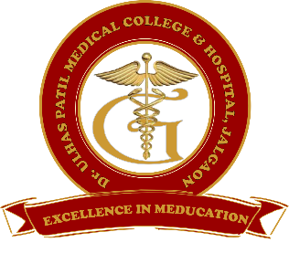 | Godavari Foundation’s  DR. ULHAS PATIL MEDICAL COLLEGE & HOSPITAL,  Recognized by Medical Council of India, Approved by Central Govt. of India, New Delhi,  Letter no. MCI-34(41)/2012-med./158127, dated 05/02/2013  Affiliated to Maharashtra University of Health Sciences, Nashik [College Code-1306]  Jalgaon-Bhusawal Road, NH-6, Jalgaon Kh, Tal. & Dist. Jalgaon 425309  Tel. No. (0257)2366657, 2366678 Fax No. 0257-2366648  Email ID : dupmcj@yahoo.in Web Site : www.dupmc.ac.in

Date: 14/06/2022
Instructional sessions for students introduced by the College on the Medical, Legal, Ethical and Social Issues involved in organ transplantation.

Dr. Ulhas Patil Medical college and hospital had been inspected and certification of recognition granted for eye bank and keratoplasty centre.
In curriculum, the topic of organ transplantation is included according to Maharashtra University of health sciences.
At following places, various aspects of the organ transplantation topic are covered.
- During foundation course at the beginning of 1st MBBS in Anatomy department.
- During clinical postings at community medicine department in second year and third year.
- Surgery department.
- During Internship orientation programme, at the beginning of each internship batch.
Content of the Organ transplantation topic:
Medical issues: Need of organ transplantations, disease conditions in which organ transplantation are required, HLA typing, Brain death and its certification, organ retrieval, storage, transportation and transplantation, Brief description of procedures, Drugs used in immune-suppression.
Ethical issues: consent of patient in case of live donors, consent and counseling of relatives in case of cadaveric donation, opt-in, opt-out systems of organ donor registries in world, who should get organ donations on priority etc.
Legal issues:
Transplantation of Human Organs and Tissues Act (THOTA),
National Organ Transplant Program (NOTP)
Social issues: Organ availability, importance of organ donation, social factors affecting organ donation, religious factors behind organ donation, social taboos related to organ donation, creating awareness regarding organ donation etc.
Thus the importance of organ transplantation is very well covered in academic activities at Dr. Ulhas Patil Medical College.

Prepared by Coordinator Dean

